1. VERSION 1.1

mkdir devops

cd devops

docker pull nginx

docker run -itd --name webpage -p 8080:80 nginx

docker ps

localhost:8080

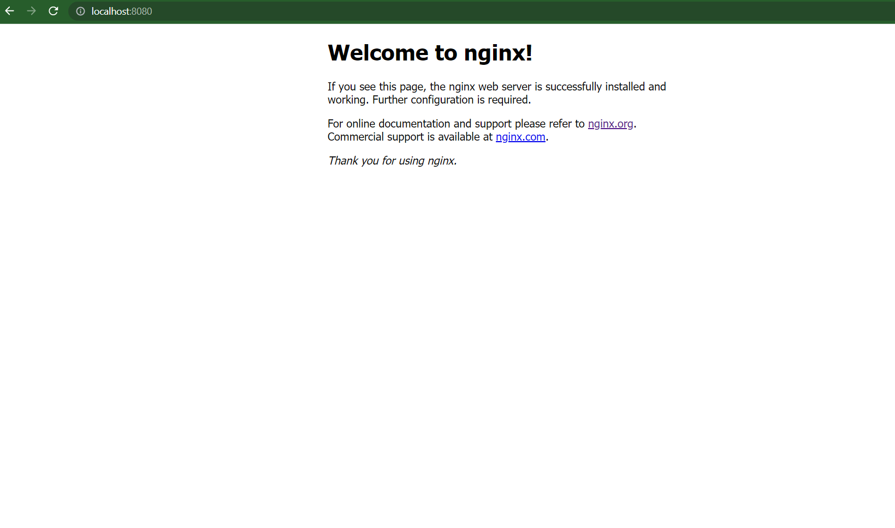

1. VERSION 2.1

vi index.html

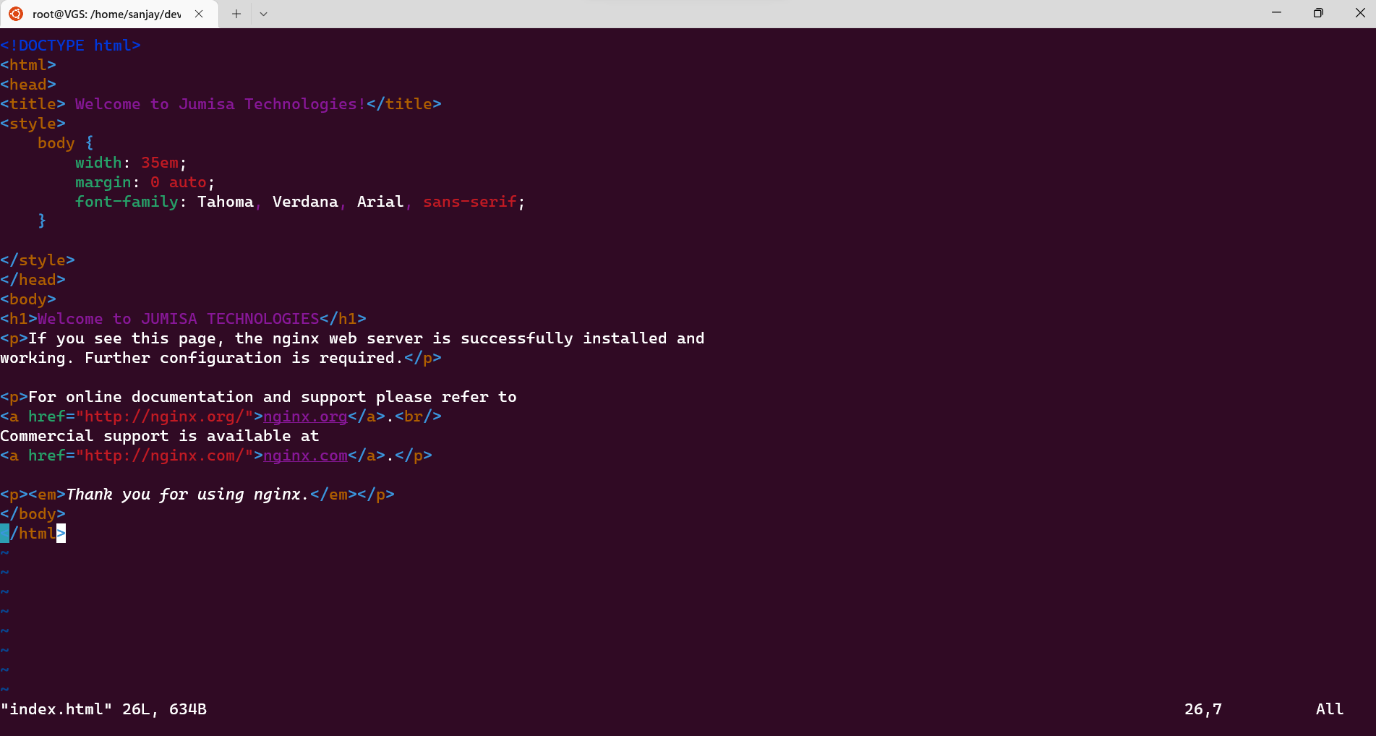

vi Dockerfile

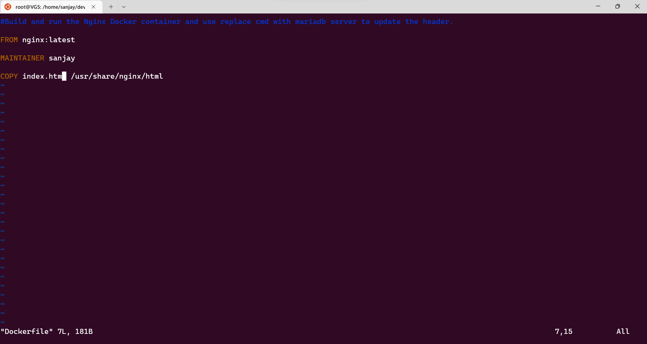

Remove the existing container

docker build -t nginx .

docker run -itd --name myweb -p 8080:80 nginx

docker ps

localhost:8080

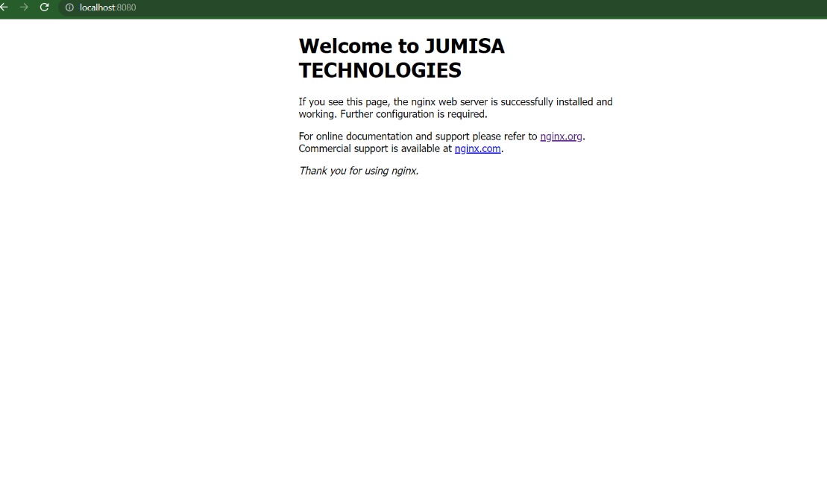

3.VERISON 3.1

Remove the existing containers

vi index.html

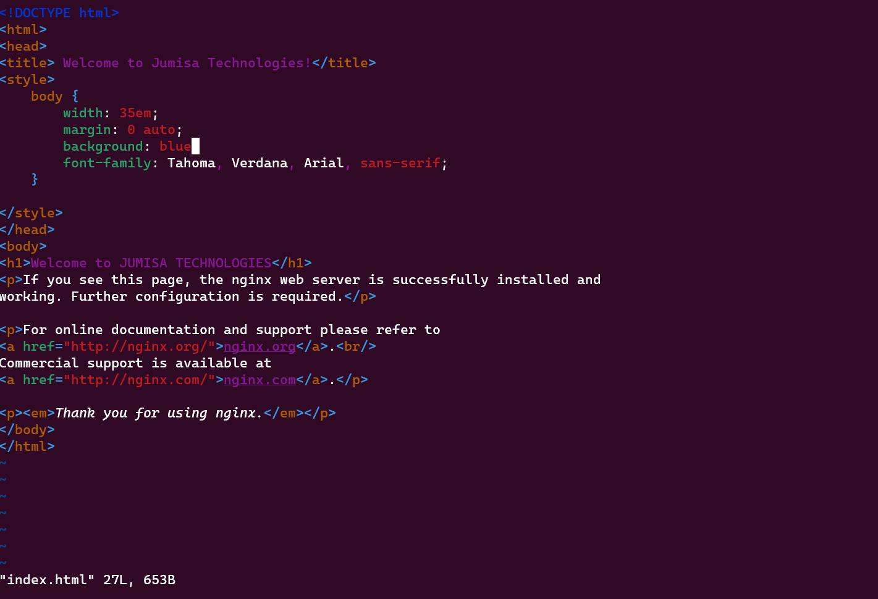

docker build -t nginx .

docker run -itd --name jumisawebpage -p 8080:80 nginx

docker ps

localhost:8080

